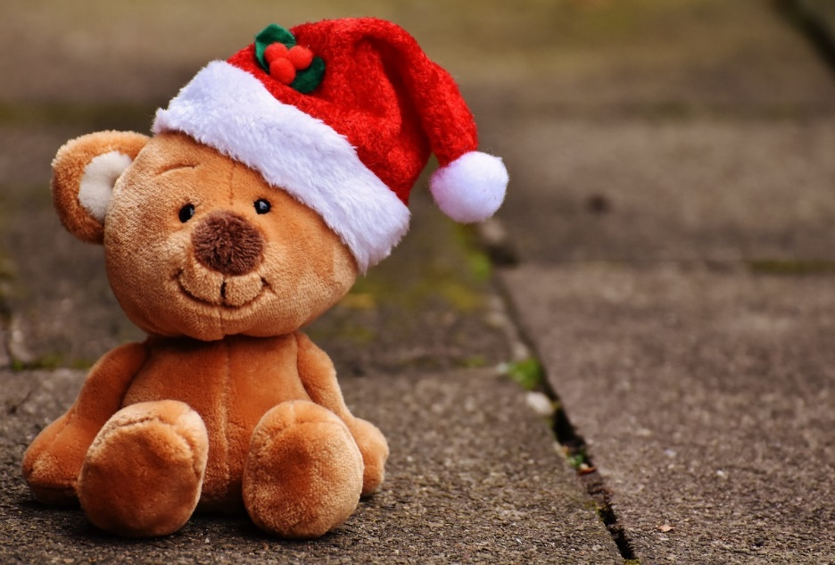TEDDY BEAR:

A **teddy bear** is a stuffed toy in the form of a bear. A teddy bear is a traditional and timeless toy and is often given Teddy bears have always been popular because of their exceptional benefits, especially for childrens.